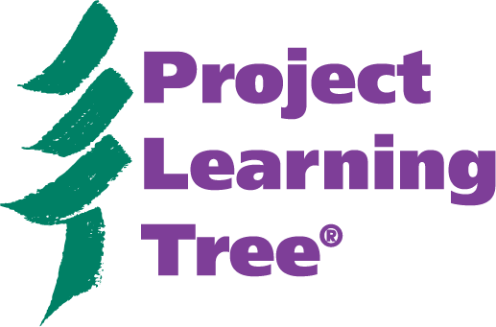
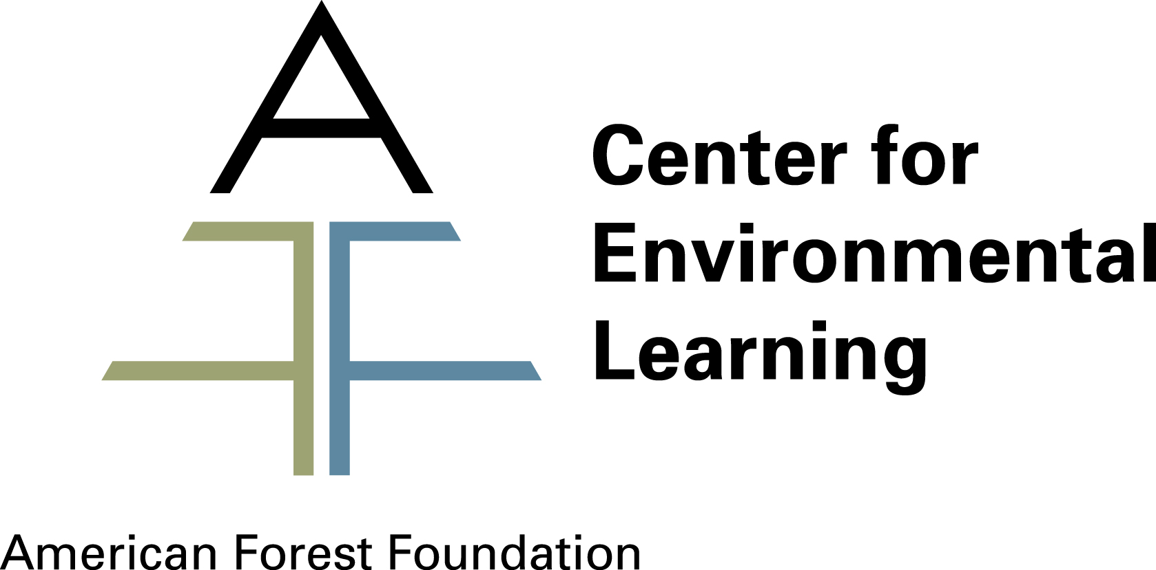

Information for State Sponsors

Thank you for your interest in sponsoring Project Learning Tree (PLT) in [STATE]. Below is background information about PLT and how this environmental education program is disseminated to teachers in all 50 states and abroad. Beginning on page five, we outline the responsibilities of state sponsors and the national PLT office in implementing the program.

Background Information
Project Learning Tree® (PLT) is an environmental education program of the American Forest Foundation’s Center for Environmental Learning. PLT provides educators and students in grades PreK-12 with comprehensive environmental education curriculum resources that can be integrated into lesson plans for all grades and subject areas. Through indoor and outdoor hands-on, multi-disciplinary activities, PLT develops critical thinking skills and teaches students how to think, not what to think about complex environmental issues. PLT helps students learn the skills they need to make sound choices about the environment. Developed in 1976, PLT has an international network of more than 500,000 trained educators using PLT materials that cover the total environment. The American Forest Foundation, a nonprofit organization, works for healthy forests, quality environmental education, and informed decision-making about our communities and our world.

The goals of PLT include:
- create awareness, appreciation, understanding, skills and commitment to address environmental issues
- provide a framework for youth to apply scientific processes and higher order thinking skills to resolve environmental problems
- increase appreciation and tolerance of diverse viewpoints on environmental issues by developing attitudes and actions based on analysis and evaluation of the available information
- stimulate creativity, originality and flexibility to resolve environmental problems and issues
- encourage youth to become responsible, productive and participatory members of society.

The PLT program has been sustained for more than 30 years with continuous funding and support from partner organizations. PLT spawned the development of Project WILD in 1983 and Project WET in 1992. Both were built on the PLT model.

How Project Learning Tree Works
Not only has PLT created a series of quality curriculum materials, but also a comprehensive system of delivering these materials to educators that ensures their effective use with students. PLT was one of the first environmental education programs in the U.S. to establish a protocol of professional development as part of its methodology.

The PLT program consists of three essential elements:
- high-quality materials
- diverse network of professional educators and resources specialists
- successful delivery system/professional development model

1. High-quality materials
PLT materials are developed in partnership with other organizations and undergo an extensive evaluation process. Hundreds of professional educators and technical experts review, field test, and independently evaluate all of PLT’s curriculum materials. PLT materials stay on the leading edge of quality environmental education through continuous review, revision, and evaluation.

The development and design of PLT materials is a complex process built upon research of what educators need, for example, standards-based lessons. PLT materials are supplementary, not a replacement, to the curriculum. PLT lessons help teachers teach what they’re supposed to teach.

To ensure PLT supports the needs of educators, PLT uses an extensive multi-layered curriculum development process to guide the creation of its materials. This process includes research, surveys, writing workshops, and reviews with educators and resource professionals; revisions based on pilot testing and field testing in the classroom; and formal assessment of impact on student learning by independent evaluators.

PLT materials have been reviewed formally (in a controlled environment) using both formative (review of content accuracy, checked for bias, pedagogy) and summative (pre-test, intervention lessons, post-test) evaluation. Students were shown to have made gains in overall knowledge and skills.

PLT materials were used as “model curriculum” by the North American Association for Environmental Education’s Guidelines for Excellence program.

PLT lessons are aligned with national standards, including those for science, social studies, environmental education, and guidelines developed by the Girl Scouts of America. Over 40 states have also aligned PLT to their state academic standards.
- In [state], PLT activities have been aligned to standards for [list]

2. Network
PLT is distinguished by the quality, commitment, and extent of its network of:

- Sponsoring organizations
The PLT partners (nationally and locally) are a diverse network of sponsoring organizations (government agencies, universities, non-profit, industry) who carry out the PLT program in their local area. PLT has a partnership commitment from sponsoring organizations in almost all 50 states, the Peace Corps and several nations (Mexico, Japan, Philippines, Slovakia currently). The PLT partnership is described in a Memorandum of Understanding (MOU) between the sponsoring agency and the American Forest Foundation.
  - Since [date], [name] has sponsored PLT in [state].
  - In [date], a formal MOU was signed between [organization name(s)] and AFF.
  - Formerly ([dates]) PLT was supported by [name].

- Steering committees
The sponsoring organizations implement PLT in their state through steering committees with representatives from state education, resource, and environmental agencies; non-formal education; preK-12 schools and school districts; universities; business groups; non-profits and professional organizations, all of whom have an interest in the PLT program.

- State coordinators
Steering committees identify PLT coordinators for their states, often a paid employee of one of the implementing partners.

- Facilitators
State coordinators recruit and train facilitators to lead workshops.
  - Nationally there are ~2500 certified PLT facilitators (trainers). These “partners” are staffs at nature centers, school districts, museums, youth organizations (e.g. scouts), industry, and other agencies.
  - In [state], currently there are [number] facilitators.

- Local partnerships
At the state level, PLT sponsoring organizations also form partnerships with community groups and agencies who agree to partner the state PLT program and often provide professional development workshops and certified facilitators. PLT partners and facilitators voluntarily integrate the PLT program into their own programs. Depending on the state, the PLT sponsoring organization may provide PLT materials at no cost to local partners and volunteers in order to implement professional development workshops.

At the national level, PLT’s partners include Federal agencies (such as BLM, EPA, NOAA, and the USDA Forest Service), industry, environmental organizations, educators, and academics.

In other countries, PLT partners with an international organization or government agency that shares PLT’s mission, goals, and instructional strategies. International partners adapt, translate, and deliver a version of PLT for use in their country.

PLT’s national office oversees a “model program initiative” to strengthen and support the delivery of the PLT program at the state level. It sets forth the essential elements of a PLT program and typical best management practices that help a program achieve success and keep pace with change. It includes a self-evaluation tool to help improve the functioning of PLT programs and partners (including the national office, state programs, international programs, assorted sponsors and partners) within the network.

3. Delivery System
Educators receive PLT materials by participating in a professional development workshop. More than 25,000 educators attend our workshops annually. Most come because a colleague told them PLT is an environmental education program that works.

More than 2,000 workshops are held every year in communities across the country by “highly qualified” facilitators who are employees of school districts, nature centers, agencies, and organizations. PLT facilitators receive special training in two to three day workshops in order to represent the program.

PLT’s state and local leadership use a variety of models to organize PLT workshops, which can be tailored for specific schools, audiences (including preservice college students) or interests, and often fulfill continuing education professional development requirements.

More than 500,000 educators have attended a PLT workshop since the program’s inception. Nationally, ~2,000 workshops are designed and delivered annually, reaching 25,000+ educators every year.
  - Currently in [state], ~ [number] workshops/[number] participants annually.

How does PLT inspire students’ to take responsibility for the environment?
The PLT program and its delivery system directly targets educators and indirectly students. The PLT materials espouse the philosophy of “teaching children how to think, not what to think”. They also follow the definition of environmental education as determined by the international community of environmental educators” – that is, environmental education is a life-long process of building “awareness, knowledge and skills, and taking action” that benefits the environment (thus sustaining ecological and human systems).

When educators use PLT activities and in turn students are able to show they can use/apply the concepts embedded in the activity, they inherently demonstrate they are beginning to “take care of the environment”.

In the early 1990’s AFF established a service-learning grant program, GreenWorks!. Grants up to $5,000 are available to PLT educators and their students who take community action to improve their neighborhood environment. Over 700 grants have been awarded nationally to communities across the country. GreenWorks! projects are connected to the curriculum. They empower students to take action to improve the environment in their neighborhood based on what they learned in the classroom. At this level of academic and personal involvement with environment-based concepts (both cross disciplinary and interdisciplinary), students are directly involved with “taking responsibility for the environment”.

State Sponsorship of PLT
In order to establish a PLT program in a state there must be at least one sponsoring organization that administers that state’s PLT program and disseminates PLT materials to educators through professional development workshops. For example, in a number of states the Department of Forestry is the PLT sponsor, while in other states it is the Department of Environmental Protection, Department of Education, a non-profit, or a university. The sponsoring organization(s) must sign a Memorandum of Understanding (MOU) with national PLT before becoming an official sponsor.

By signing on as a state sponsor of PLT, the organization verifies it supports PLT and its mission and goals, and will use its resources to help achieve PLT’s mission and goals. Likewise, such an agreement indicates that AFF supports the sponsor’s mission and goals, since the relationship that is established is mutual. In addition, AFF makes pass-through funding available to state sponsors that have a signed MOU with AFF in order to help promote and advance activities associated with PLT.

Typically, the MOU is valid for three years and can be renewed in writing if agreed to by both parties. Either party may terminate the agreement by giving 90 days written notice to the other party. In the event that PLT state sponsorship changes hands or expands to include additional organizations, depending on the needs and growth of the PLT program, a new MOU must be established with national PLT.

In many states, multiple organizations work together as co-sponsors of the PLT program. Each co-sponsor should provide at least one of the following: a PLT State Coordinator, in-kind services, funding, fiscal management, or marketing and promotion of PLT. When there is more than one sponsor, it is important to establish the role of each co-sponsor through an MOU signed at the state level between all the co-sponsors.

State sponsor(s) of PLT agree to:
- Provide a state coordinator who will assume the responsibility of administering/ coordinating the PLT program at the local level. The primary responsibility of the state coordinator is to initiate, supervise, and maintain PLT activities in the state, including training qualified facilitators and developing an annual work plan.
- Establish a steering committee, consisting of stakeholders from within the local community. The purposes of a state steering committee include: setting objectives and procedures to promote PLT in the state, assisting in raising funds for the state program, using various methods to evaluate the success and usefulness of the state PLT program, and developing a state work plan and budget.
- Establish within the community a facilitator network for the delivery of the program. Facilitator training and workshop delivery will be accomplished according to the framework recommended by PLT.
- Provide appropriate office space and administrative support to implement and support the PLT program. This includes documenting all PLT workshops and presentations held in the state, forwarding all completed survey forms (facilitator, educator, etc) to the PLT National Office, and completing the annual PLT state reporting form.
- Provide funding and support to maintain the program at the local level. Many PLT state programs need to raise money to fund their PLT activities and often the coordinator’s salary. The steering committee usually takes the lead with assistance from the coordinator. The coordinators’ conference usually has at least one session to help with fundraising.
- Development of a state plan for the PLT program to guide the implementation of PLT within the state. Plan should include: assigned roles and responsibilities of the sponsoring agencies, responsibilities of state coordinator, selection methods for steering committee, implementation plan and schedule, projections for the number of activity guides to be purchased, and development of a state PLT budget.

In addition, the American Forest Foundation agrees to:
- Provide to Local Sponsor the right to distribute and use all appropriate PLT materials.
- Make available all appropriate PLT materials for purchase from a central printing source at least once a year.
- Provide assistance and recommendations for program implementation, coordinator training and facilitator/network development.
- Provide a standing invitation to attend the annual International Coordinators’ Conference at the Local Sponsor’s expense. Depending upon available funding, some financial assistance may be available from AFF.
- Provide a standing invitation to attend all meetings of the PLT Education Operating Committee as a non-voting participant at the Local Sponsor’s expense.
- Provide access to the PLT listserv and the “Branch,” PLT’s electronic newsletter.
- Provide regular updates concerning the PLT program’s progress at the national level, as well as regular communication concerning the status of environmental education at the national level.
- Grant Permission to PLT Local Sponsor to link to the PLT website, www.plt.org.

And both parties agree:
- That the cost of the materials sold to the Local Sponsor will be sufficient to cover production and development as required.
- That the use of the PLT materials will adhere to all copyright laws and PLT reprint policies.
- That the Local Sponsor’s use of AFF/PLT logos and symbols on documents, reports or other products derived from this program will be subject to the Service Mark License granted in the MOU.

Thank you for your interest in Project Learning Tree. For more information, please contact:

Rachel Bayer or Vanessa Bullwinkle
Manager of Operations Director of Operations and Marketing
Project Learning Tree Project Learning Tree
202.463.2751 202.463.2472
rbayer@plt.org vbullwinkle@plt.org

