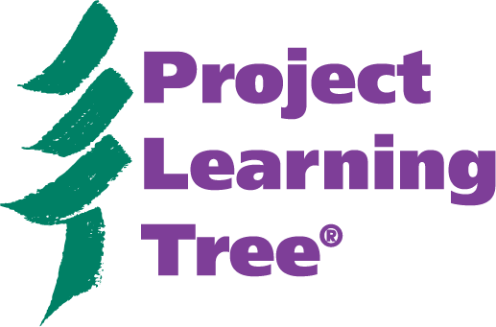
Project Learning Tree
Hike through the PreK-8 Environmental Education Activity Guide

1. What are the goals of PLT?

2. What are “invasive species” and where can you find this information?

3. What is the role of the teacher in presenting controversial issues?

4. Find an activity that addresses the theme of diversity and can be conducted indoors.

5. Where can you find information about “Differentiated Instruction”? Give an example of how differentiated instruction is used in an activity, and describe the corresponding icon.

6. Where can you find information to help evaluate the effectiveness of activities with your students?

7. Where can you find examples of “storylines”?

8. What are three teaching methods/strategies used by PLT to guide learners through the process of awareness, understanding, challenge, motivation, and action”?

9. How many activities deal with the “urban environment”?

10. What is the fastest way to find an activity in a particular curriculum area (e.g. math, language arts, science, etc.)?

11. Find an activity that involves the skill “estimating.”

12. What are three ways of finding out how technology is used in PLT activities? Give one example of a technology connection used in a PLT activity.

13. Which Appendix provides extensive “activity references and resources”?

14. What are the 9 items that can be found in the sidebar of the activities?

15. What is PLT’s policy about reproducing/copying materials from the PLT guide?

16. What radio program is embedded into Activity 84? Where can you find additional information about PLT’s partnership with this program?

17. Where can you find a sample rubric for the third assessment opportunity in “Get in Touch with Trees”?

18. Reading connections are emphasized in the new guide. Where can you find them? Name one book that you are familiar with.

19. What is PLT’s slogan that sums up how PLT supports quality EE?

20. How can I find PLT correlations to my subject area standards?


Project Learning Tree® is the environmental education program of the American Forest Foundation and sponsored in [state name] by [PLT local sponsor].
Project Learning Tree
Hike through the Prek-8 Environmental Education Activity Guide
Answers

1. What are the goals of PLT?
p. 3

2. What are “invasive species” and where can you find this information?
Glossary, p. 422

3. What is the role of the teacher in presenting controversial issues?
Appendix 12, p. 448

4. Find an activity that addresses the theme of diversity and can be conducted indoors.
“Environmental Exchange Box,” p. 92; found using Index 3: Time Consideration and Setting Index, p. 459

5. Where can you find information about “Differentiated Instruction”?
Introduction, p.6 and Appendix 7, p. 442
Give an example of how differentiated instruction is used in an activity, and describe the corresponding icon.
“Water Wonders”, p. 188, uses paired/cooperative learning; 2 stick figures

6. Where can you find information to help evaluate the effectiveness of activities with your students?
See “Assessment Opportunity” next to “Objectives” at the beginning of each activity

7. Where can you find examples of “storylines”?
Appendix 3, p. 429

8. What are three teaching methods/strategies used by PLT to guide learners through the process of awareness, understanding, challenge, motivation, and action”?
Discussion, brainstorming, and planning; found on p. 5-6, “PLT Teaching Methods and Strategies”

9. How many activities deal with the urban environment?
19; Index 5: Topic Index, under “Urban Environment,” p. 467

10. What is the fastest way to find an activity in a particular curriculum area (e.g. math, language arts, science, etc.)?
Index 1: Subject Index, p. 455

11. Find an activity that involves the skill “estimating.”
Index 6: Skills Index, “Every Drop Counts!” p. 468

12. What are three ways of finding out how technology is used in PLT activities?
Appendix 8: Technology Connections, p. 443-444; Technology Connections in sidebar of each activity; and Index 4: Technology Connections Index, p. 461.
Give one example of a technology connection used in a PLT activity.
Presentation software in “Habitat Pen Pals”; found in Index 4

13. Which Appendix provides extensive “activity references and resources”?
Appendix 4, p. 431

14. What are the 9 items that can be found in the sidebar of the activities?
Levels, Subjects, Concepts, Skills, Differentiated Instruction (not in all activities), Technology Connections (not in all activities), Materials, Time Considerations, and Related Activities; found in Introduction’s “Activity Components,” p. 10

15. What is PLT’s policy about reproducing/copying materials from the PLT guide?
See inside of front cover

16. What radio program is embedded into Activity 84?
Earth & Sky
And where can you find additional information about PLT’s partnership with this program?
Appendix 5, p. 441

17. Where can you find a sample rubric for the third assessment opportunity in “Get in Touch with Trees”?
p. 20, PLT website at www.plt.org (Go to → Curriculum/PreK-8/Resources for 2006 PreK-8 Guide by Activity)

18. “Reading Connections” are emphasized in the new guide. Where can you find them?
In a shaded box at the end of each activity
Name one book that you are familiar with.

19. What is PLT’s slogan that sums up how PLT supports quality EE?
“Helping students learn how to think, not what to think”, p. 3

20. How can I find PLT correlations to my subject area standards?
PLT website, www.plt.org, p. 4

Project Learning Tree® is the environmental education program of the American Forest Foundation and sponsored in [state name] by [PLT local sponsor].

