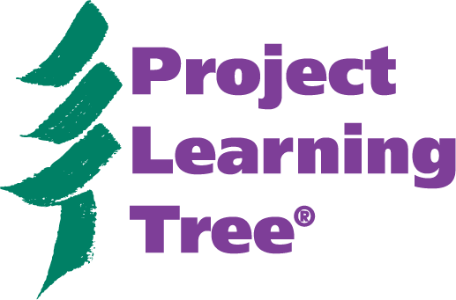
Project Learning Tree Secondary Module

Hike through the Guide
Exploring Environmental Issues: Places We Live

- Where is the copyright information, and what are the stipulations for reprinting PLT materials without permission?

- Where can you find information on the purpose of the Module?

- How many pages is the section, “Background Information for Educators”?

- Where can you find correlations to the national science and social studies standards?

- Where can you find the objectives for each activity?

- How do you know if a word/term can be found in the glossary?

- Where can you find the subjects that each activity addresses?

- Where can you find information about the conceptual framework for PLT?

- Which activity covers the topic of urban forests?

- In which activity do students explore how the choices we make about the foods we eat, the products we purchase, and the communities we develop affect distant communities?

- Where can you find information on maps, data, and how to find information for your community?

- What are PLT’s five themes?

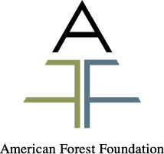
Project Learning Tree® is the environmental education program of the American Forest Foundation and sponsored in [state name] by [PLT local sponsor].
Project Learning Tree Secondary Module
Hike through the Guide
Exploring Environmental Issues: Places We Live
Answers

- Where is the copyright information, and what are the stipulations for reprinting PLT materials without permission?
Inside the front cover. Only student pages may be reproduced without permission.

- Where can you find information on the purpose of the Module?
Introduction, Page 12

- How many pages is the section, “Background Information for Educators”?
10 pages, pages 15-24

- Where can you find correlations to the national science and social studies standards?
Appendix H, Appendix I

- Where can you find the objectives for each activity?
In the green box on the first page of each activity

- How do you know if a word/term can be found in the glossary?
It is in italics and highlighted in bold type.

- Where can you find the subjects that each activity addresses?
The green sidebar of each activity

- Where can you find information about the conceptual framework for PLT?
Appendix J

- Which activity covers the topic of urban forests?
Activity 5 – Green Space

- In which activity do students explore how the choices we make about the foods we eat, the products we purchase, and the communities we develop affect distant communities?
Activity 7 – Far Reaching Decisions

- Where can you find information on maps, data and how to find information for your community?
Appendix C

- What are PLT’s five themes?
Appendix J - Diversity; Interrelationships; Systems; Structure and Scale; Patterns of Change

Project Learning Tree® is the environmental education program of the American Forest Foundation and sponsored in [state name] by [PLT local sponsor].

