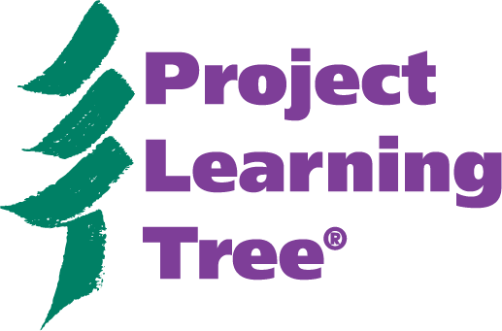
PLT’s Energy & Society Materials

Hike Through the Kit

Answer the following questions and specify where you found the information.

1. What song contains the lyrics, “The atom’s nucleus is charged positive / it’s where the positive proton and neutral neutron live / the nucleus is orbited by the electrons / which are negatively charged and always moving on”?

2. How much food does an adult giraffe eat in a day?

3. One song is presented in both English and Spanish. What is the title of the song in both languages?

4. What is a foot-pound and what is it used to measure?

5. Which national education standards are met by the Energy & Society concept, “Individuals can impact the environment through their energy choices.”

6. Step-by-step dance instructions are provided for which songs?

7. What children’s literature for ages 4-8 is related to geothermal energy?

8. What are the typical sources of energy for today’s hybrid cars?

9. Which activity is contained in both PLT’s PreK-8 Environmental Education Activity Guide and PLT’s Energy & Society Activity Guide?

- What is the second educational objective for Activity 3: Energy Chains?
- What poster is used in Activity 1: Energy Detectives?
- What other PLT activities are related to Activity 4: What Powers the Move?
- What are the four categories of the Energy Challenge Game?
- What subjects are covered in Activity 2: May the Source Be with You?

Bonus Question

For what age levels are the songs and dance instructions the most appropriate?
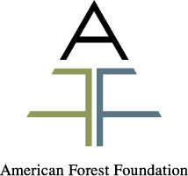
Project Learning Tree® is the environmental education program of the American Forest Foundation and sponsored in [state name] by [PLT local sponsor].

PLT’s Energy & Society Materials
Hike Through the Kit

Answers

Answer the following questions and specify where you found the information.

1. What song contains the lyrics, “The atom’s nucleus is charged positive / it’s where the positive proton and neutral neutron live / the nucleus is orbited by the electrons / which are negatively charged and always moving on”?
#5 Energy. Source: CD liner notes and Energy & Society Activity Guide, Appendix III, page 70.

2. How much food does an adult giraffe eat in a day?
75 pounds of food. Source: Where is the energy? poster.

3. One song is presented in both English and Spanish. What is the title of the song in both languages?
#6 Energy and Me and #7 Energia Y Yo. Source: CD liner notes and Energy & Society Activity Guide, Appendix III, page 71.

4. What is a foot-pound and what is it used to measure?
A foot-pound is the energy required to raise a one pound object one foot from the Earth’s surface. It is used as a measurement in mechanical energy. Source: Energy & Society Activity Guide, Part Two: Background Information for Educators, page 13.

5. Which national education standards are met by the Energy & Society concept, “Individuals can impact the environment through their energy choices.”
Science: K-4 and 5-8: Standard F. Social Studies: Early Grades: Standard IXe. English Language Arts: Standard 11. Source: Energy & Society Activity Guide, Part One: Introduction, page 9.

6. Step-by-step dance instructions are provided for which songs?
Energy & Me, Water Cycle, and It is the Energy, It is the Sun. Source: Energy & Society Activity Guide, Appendix III, page 75.

7. What children’s literature for ages 4-8 is related to geothermal energy?
Geysers, The Magic School Bus Blows Its Top: A Book about Volcanoes, and Planet Earth. Source: Energy & Society Activity Guide, Appendix II, page 65-66.

8. What are the typical sources of energy for today’s hybrid cars?
There are two sources: a fuel-efficient gas engine and an electric motor. Source: What powers the move? poster and Energy & Society Activity Guide, Appendix IV, page 76.

9. Which activity is contained in both PLT’s PreK-8 Environmental Education Activity Guide (eighth edition, 2001) and PLT’s Energy & Society Activity Guide?
In the Driver’s Seat. Source: Energy & Society Activity Guide, Contents, page 1 and Appendix V, Project Learning Tree Connections, page 79.

Project Learning Tree® is the environmental education program of the American Forest Foundation and sponsored in [state name] by [PLT local sponsor].

- What is the second educational objective for Activity 3: Energy Chains?
Students will be able to explain The Law of Conservation of Energy. Source: Energy & Society Activity Guide, Part Four: Activity 3, page 36.

- What poster is used in Activity 1: Energy Detectives?
Where is the Energy? Source: Energy & Society Activity Guide, Part Four: Activity 1, page 25, Part A, #6.

- What other PLT activities are related to Activity 4: What Powers the Move?
#53: On the Move, #55: Planning the Ideal Community, #85: In the Driver’s Seat, and #86: Our Changing World. Source: Energy & Society Activity Guide, Part Four: Activity 4, page 42.

- What are the four categories of the Energy Challenge Game?
Forms of Energy, Renewable Energy Sources, Potential or Kinetic, and Energy & Society. Source: Energy & Society Activity Guide, Part Four: Activity 6, page 52.

- What subjects are covered in Activity 2: May the Source Be with You?
Language Arts, Science, Social Studies, Art. Source: Energy & Society Activity Guide, Part Four: Activity 2, page 32.

Bonus Question

For what age levels are the songs and dance instructions the most appropriate?
While all the songs and dances are appropriate for all ages, Energy & Me and Water Cycle feature younger kids and use simpler dance moves. It is the Energy, It is the Sun, Resources, and Energy feature older kids and the dance steps are more complex. Source: Energy & Society Activity Guide, Appendix III, page 75.

Project Learning Tree® is the environmental education program of the American Forest Foundation and sponsored in [state name] by [PLT local sponsor].

